Food Waste Hierarchy

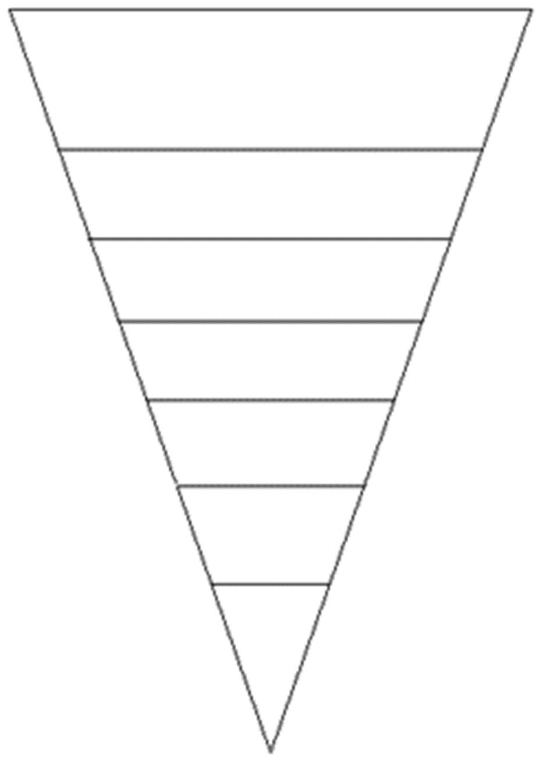
LOW
Feed animals
Redistribute to people
Prevent Waste
Compost
Burn for energy
Anaerobic digestion
for energy
Landfill

Food Waste Hierarchy

HIGH
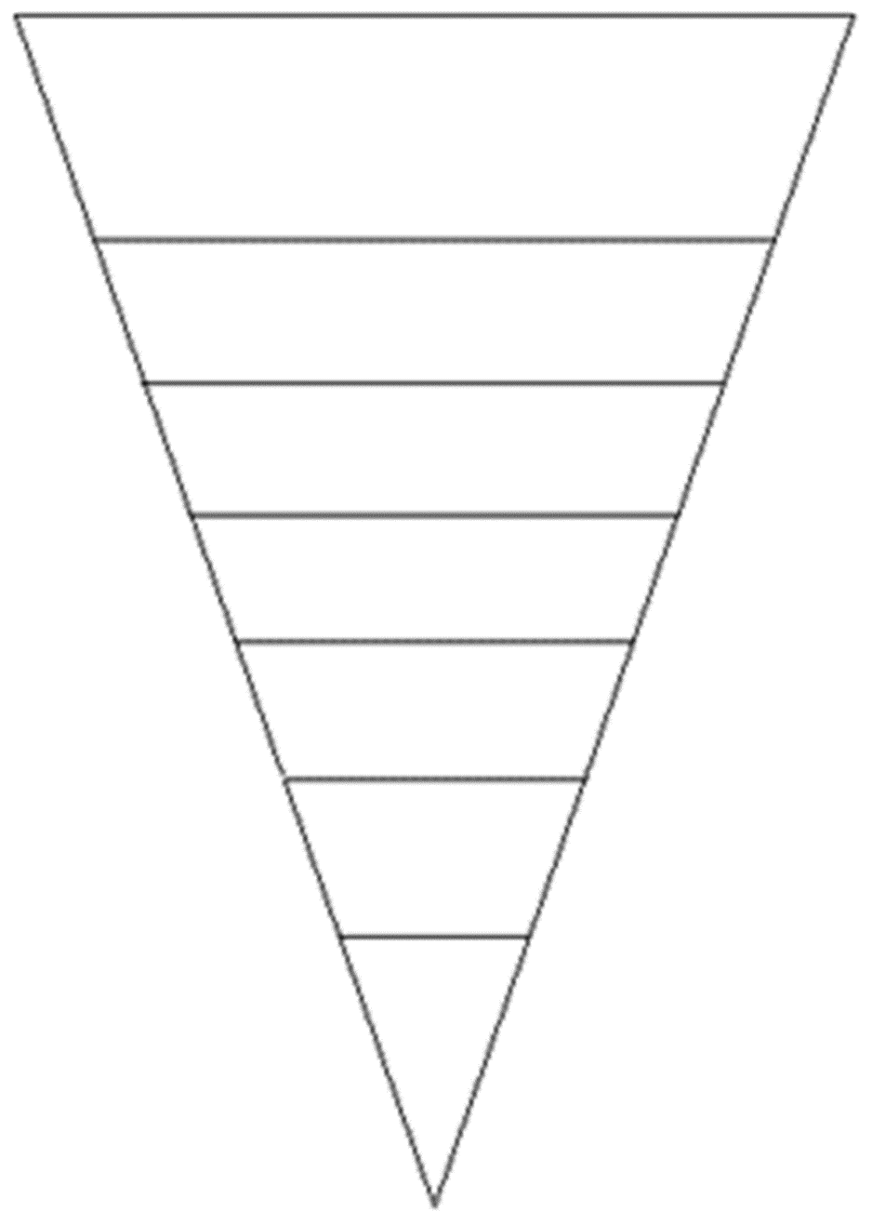
LOW
Fill in the food waste hierarchy on the right using the following options, from most to least preferable:
  - Compost
  - Redistribute to people
  - Feed animals
  - Landfill
  - Anaerobic digestion for energy
  - Prevent waste
  - Burn for energy

Compost Compost

Redistribute to people Redistribute to people

Feed animals Feed animals

Landfill Landfill

Anaerobic digestion for energy Anaerobic digestion for energy

Prevent waste Prevent waste

Burn for energy Burn for energy

Compost Compost

Redistribute to people Redistribute to people

Feed animals Feed animals

Landfill Landfill

Anaerobic digestion for energy Anaerobic digestion for energy

Prevent waste Prevent waste

Burn for energy Burn for energy

